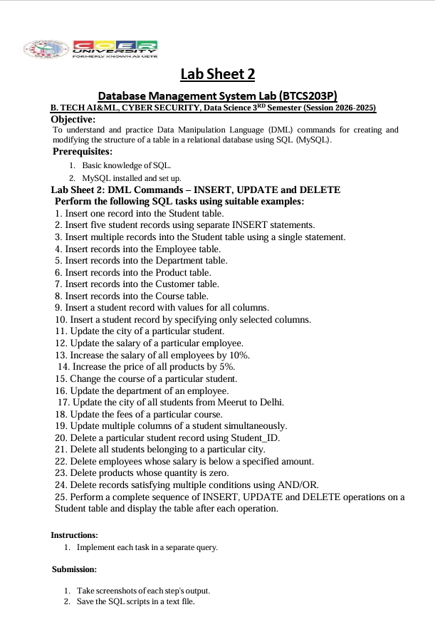

1. Insert one record into the Student table.
=DROP DATABASE IF EXISTS CollegeDB;
CREATE DATABASE CollegeDB;
USE CollegeDB;
CREATE TABLE Student (
Student_ID INT PRIMARY KEY,
Student_Name VARCHAR(50),
Father_Name VARCHAR(50),
Age INT,
City VARCHAR(50),
Course VARCHAR(50)
);
CREATE TABLE Employee (
Employee_ID INT PRIMARY KEY,
Employee_Name VARCHAR(50),
Salary DECIMAL(10,2),
Department VARCHAR(50)
);
CREATE TABLE Department (
Department_ID INT PRIMARY KEY,
Department_Name VARCHAR(50),
Location VARCHAR(50)
);
CREATE TABLE Product (
Product_ID INT PRIMARY KEY,
Product_Name VARCHAR(50),
Price DECIMAL(10,2),
Quantity INT
);
CREATE TABLE Customer (
Customer_ID INT PRIMARY KEY,
Customer_Name VARCHAR(50),
City VARCHAR(50),
Phone VARCHAR(15)
);
CREATE TABLE Course (
Course_ID INT PRIMARY KEY,
Course_Name VARCHAR(50),
Fees DECIMAL(10,2)
);

INSERT INTO Student
VALUES (101, 'Divya Verma', 'Pradeep Verma', 19, 'Saharanpur', 'B.Tech Data Science');
SELECT*FROM Student;

2. Insert five student records using separate INSERT statements.
=INSERT INTO Student VALUES
(109, 'Aman Kumar', 'Rakesh Kumar', 20, 'Delhi', 'B.Tech CSE');
INSERT INTO Student VALUES
(103, 'Priya Sharma', 'Mohan Sharma', 19, 'Meerut', 'BCA');
INSERT INTO Student VALUES
(104, 'Rahul Singh', 'Suresh Singh', 21, 'Roorkee', 'B.Tech IT');
INSERT INTO Student VALUES
(105, 'Neha Gupta', 'Raj Gupta', 20, 'Delhi', 'B.Sc CS');
INSERT INTO Student VALUES
(106, 'Karan Verma', 'Anil Verma', 19, 'Meerut', 'B.Tech CSE');
SELECT*FROM Student;
3. Insert multiple records into the Student table using a single statement.
INSERT INTO Student
(Student_ID, Student_Name, Father_Name, Age, City, Course)
VALUES
(107, 'Anjali', 'Ramesh', 19, 'Haridwar', 'B.Tech DS'),
(108, 'Vikas', 'Mahesh', 20, 'Dehradun', 'BCA'),
(110, 'Simran', 'Rajiv', 19, 'Delhi', 'B.Tech CSE');
SELECT * FROM Student;

4. Insert records into the Employee table.
=INSERT INTO Employee VALUES
(201, 'Amit Sharma', 35000, 'IT');
INSERT INTO Employee VALUES
(202, 'Riya Gupta', 42000, 'HR');
INSERT INTO Employee VALUES
(203, 'Rohit Singh', 28000, 'Sales');
INSERT INTO Employee VALUES
(204, 'Neha Verma', 50000, 'Finance');
select*from employee;

5. Insert records into the Department table.
=INSERT INTO Department VALUES
(1, 'IT', 'Delhi');
INSERT INTO Department VALUES
(2, 'HR', 'Roorkee');
INSERT INTO Department VALUES
(3, 'Finance', 'Haridwar');
INSERT INTO Department VALUES
(4, 'Sales', 'Meerut');
select*from department;
6. Insert records into the Product table.
=INSERT INTO Product VALUES
(301, 'Laptop', 55000, 10);
INSERT INTO Product VALUES
(302, 'Mouse', 500, 25);
INSERT INTO Product VALUES
(303, 'Keyboard', 1000, 15);
INSERT INTO Product VALUES
(304, 'Monitor', 12000, 5);
INSERT INTO Product VALUES
(305, 'Printer', 8000, 0);
select*from product;

7. Insert records into the Customer table.
=INSERT INTO Customer VALUES
(401, 'Rahul Kumar', 'Delhi', '9876543210');
INSERT INTO Customer VALUES
(402, 'Priya Singh', 'Meerut', '9876543211');
INSERT INTO Customer VALUES
(403, 'Ankit Sharma', 'Roorkee', '9876543212');
INSERT INTO Customer VALUES
(404, 'Neha Gupta', 'Haridwar', '9876543213');
select*from customer;
8. Insert records into the Course table.
=INSERT INTO Course VALUES
(501, 'B.Tech Data Science', 90000);
INSERT INTO Course VALUES
(502, 'B.Tech CSE', 85000);
INSERT INTO Course VALUES
(503, 'BCA', 60000);
INSERT INTO Course VALUES
(504, 'B.Sc Computer Science', 55000);
select * from course;

9. Insert a student record with values for all columns.
=INSERT INTO Student
(Student_ID, Student_Name, Father_Name, Age, City, Course)
VALUES
(110, 'Arjun Mehta', 'Vijay Mehta', 20, 'Chandigarh', 'B.Tech CSE');

10. Insert a student record by specifying only selected columns.
=INSERT INTO Student
(Student_ID, Student_Name, City)
VALUES
(111, 'Pooja Sharma', 'Delhi');

11. Update the city of a particular student.
=UPDATE Student
SET City = 'Delhi'
WHERE Student_ID = 101;
SET SQL_SAFE_UPDATES = 1;
SELECT*FROM STUDENT;
12. Update the salary of a particular employee.
=UPDATE Employee
SET Salary = 40000
WHERE Employee_ID = 201;
SET SQL_SAFE_UPDATES=1;
SELECT*FROM EMPLOYEE;

13. Increase the salary of all employees by 10%.
=UPDATE Employee
SET Salary = Salary * 1.10;
select*from employee;

14. Increase the price of all products by 5%.
=UPDATE Product
SET Price = Price * 1.05;
select * from product;
15. Change the course of a particular student.
=UPDATE Student
SET Course = 'B.Tech Data Science'
WHERE Student_ID = 103;
select*from course;
16. Update the department of an employee.
=UPDATE Employee
SET Department = 'IT'
WHERE Employee_ID = 203;
select*from employee;
17. Update the city of all students from Meerut to Delhi.
=UPDATE Student
SET City = 'Delhi'
WHERE City = 'Meerut';
select*from student;
18. Update the fees of a particular course.
=UPDATE Course
SET Fees = 65000
WHERE Course_ID = 503;
select*from student;
19. Update multiple columns of a student simultaneously.
=UPDATE Student
SET Age = 21,
City = 'Haridwar',
Course = 'B.Tech Data Science'
WHERE Student_ID = 102;
select*from student;
20. Delete a particular student record using Student_ID.
=DELETE FROM Student
WHERE Student_ID = 111;
select*from student;
21. Delete all students belonging to a particular city.
=DELETE FROM Student
WHERE City = 'Delhi';
select*from student;
22. Delete employees whose salary is below a specified amount.
=DELETE FROM Employee
WHERE Salary < 30000;
select*from employee;

23. Delete products whose quantity is zero.
=DELETE FROM Product
WHERE Quantity = 0;
select*from product;

24. Delete records satisfying multiple conditions using AND/OR.
=DELETE FROM Employee
WHERE Salary < 35000
AND Department = 'Sales';
select*from employee;
25. Perform a complete sequence of INSERT, UPDATE and DELETE operations on a Student table and display the table after each operation.
=INSERT INTO Student
VALUES(120, 'Kavya Sharma', 'Raj Sharma', 19, 'Roorkee', 'B.Tech CSE');
UPDATE Student
SET City = 'Delhi'
WHERE Student_ID = 120;
SELECT * FROM Student;
UPDATE Student
SET Course = 'B.Tech Data Science'
WHERE Student_ID = 120;
SELECT * FROM Student;
UPDATE Student
SET Age = 20,
City = 'Haridwar'
WHERE Student_ID = 120;
SELECT * FROM Student;
DELETE FROM Student
WHERE Student_ID = 120;
SELECT * FROM Student;


